UNIT-IV

**Protective Relays**

A relay is automatic device which senses an abnormal condition of [electrical circuit](https://www.electrical4u.com/electric-circuit-or-electrical-network/) and closes its contacts. These contacts in turns close and complete the [circuit breaker](https://www.electrical4u.com/electrical-circuit-breaker-operation-and-types-of-circuit-breaker/) trip coil circuit hence make the circuit breaker tripped for disconnecting the faulty portion of the electrical circuit from rest of the healthy circuit. Now let’s have a discussion on some terms related to protective relay.

**Pickup Level of Actuating Signal:**  
The value of actuating quantity (voltage or current) which is on threshold above which the relay initiates to be operated.  
If the value of actuating quantity is increased, the electromagnetic effect of the relay coil is increased and above a certain level of actuating quantity the moving mechanism of the relay just starts to move.

**Reset Level:**  
The value of [current](https://www.electrical4u.com/electric-current-and-theory-of-electricity/) or [voltage](https://www.electrical4u.com/voltage-or-electric-potential-difference/) below which a relay opens its contacts and comes in original position.  
**Operating Time of Relay:**  
Just after exceeding pickup level of actuating quantity the moving mechanism (for example rotating disc) of relay starts moving and it ultimately close the relay contacts at the end of its journey. The time which elapses between the instant when actuating quantity exceeds the pickup value to the instant when the relay contacts close.  
**Reset Time of Relay:**  
The time which elapses between the instant when the actuating quantity becomes less than the reset value to the instant when the relay contacts returns to its normal position.  
**Reach of Relay:**  
A distance relay operates whenever the distance seen by the relay is less than the pre-specified impedance. The actuating impedance in the relay is the function of distance in a distance protection relay. This impedance or corresponding distance is called reach of the relay.  
Power system protection relays can be categorized into different types of relays.

[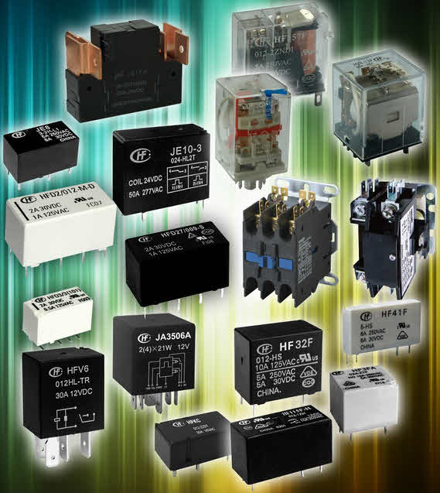](https://www.elprocus.com/wp-content/uploads/2014/03/19.jpg)

**Classification of relays**

**Based on Characteristic the protection relay can be categorized as-**

1. Definite time relays
2. Inverse time relays with definite minimum time(IDMT)
3. Instantaneous relays.
4. IDMT with inst.
5. Stepped characteristic.
6. Programmed switches.
7. Voltage restraint over current relay.

**Based on of logic the protection relay can be categorized as-**

1. Differential.
2. Unbalance.
3. Neutral displacement.
4. Directional.
5. Restricted earth fault.
6. Over fluxing.
7. Distance schemes.
8. Bus bar protection.
9. Reverse power relays.
10. Loss of excitation.
11. Negative phase sequence relays etc.

**Based on actuating parameter the protection relay can be categorized as-**

1. Current relays.
2. Voltage relays.
3. Frequency relays.
4. Power relays etc.

**Based on application the protection relay can be categorized as-**

1. Primary relay.
2. Backup relay.

Primary relay or primary protection relay is the first line of power system protection whereas [backup relay](https://www.electrical4u.com/backup-relay/) is operated only when primary relay fails to be operated during fault. Hence backup relay is slower in action than primary relay. Any relay may fail to be operated due to any of the following reasons,

1. The protective relay itself is defective.
2. DC Trip voltage supply to the relay is unavailable.
3. Trip lead from relay panel to circuit breaker is disconnected.
4. Trip coil in the circuit breaker is disconnected or defective.
5. Current or voltage signals from [CT](https://www.electrical4u.com/current-transformer-ct-class-ratio-error-phase-angle-error-in-current-transformer/) or [PT](https://www.electrical4u.com/voltage-transformer-or-potential-transformer-theory/) respectively is unavailable.

As because backup relay operates only when primary relay fails, backup protection relay should not have anything common with primary protection relay.  
**Some examples of Mechanical Relay are-**

1. Thermal
   * OT trip (Oil Temperature Trip)
   * WT trip (Winding Temperature Trip)
   * Bearing temp trip etc.
2. Float type
   * Buchholz
   * OSR
   * PRV
   * Water level Controls etc.
3. Pressure switches.
4. Mechanical interlocks.
5. Pole discrepancy relay.

**Classification of relays**

Classification or the types of relays depend on the function for which they are used. Some of the categories include protective, reclosing, regulating, auxiliary and monitoring relays.

Protective relays continuously monitor these parameters: voltage, current, and power; and if these parameters violate from set limits they generate alarm or isolate that particular circuit. These types of relays are used to protect equipments like motors, generators, and [transformers](https://www.elprocus.com/working-procedure-on-how-do-transformers-work/), and so on.

Reclosing relays are used to connect various components and devices within the system network, such as synchronizing process, and to restore the various devices soon after any [electrical fault](https://www.elprocus.com/what-are-the-different-types-of-faults-in-electrical-power-systems/)vanishes, and then to connect transformers and feeders to line network. Regulating relays are the switches that contacts such that voltage boosts up as in the case of tap changing transformers.

Auxiliary contacts are used in circuit breakers and other protective equipments for contact multiplication. Monitoring relays monitors the system conditions such as direction of power and accordingly generates the alarm. These are also called directional relays.

This article’s main aim is to give a brief idea about various relays that are employed for a wide variety of [control application](http://www.edgefxkits.com/automatic-star-delta-starter-using-relays-and-adjustable-electronic-timer-for-induction-motor)s. Some of these relays are described below.

## Different Types of Relays

Depending on the operating principle and structural features relays are of different types such as electromagnetic relays, thermal relays, power varied relays, multi-dimensional relays, and so on, with varied ratings, sizes and applications.

## Electromagnetic Relay

**Electromagnetic relays** are those relays which are operated by electromagnetic action. Modern [electrical protection relays](https://www.electrical4u.com/types-of-electrical-protection-relays-or-protective-relays/) are mainly micro processor based, but still **electromagnetic relay** holds its place. It will take much longer time to be replaced the all **electromagnetic relays** by micro processor based static relays. So before going through detail of protection relay system we should review the various **types of electromagnetic relays**.

## Electromagnetic Relay Working

Practically all the relaying device are based on either one or more of the following **types of electromagnetic relays**.

1. Magnitude measurement,
2. Comparison,
3. Ratio measurement.

Principle of **electromagnetic relay working** is on some basic principles. Depending upon working principle the these can be divided into following **types of electromagnetic relays**.

1. Attracted Armature type relay,
2. Induction Disc type relay,
3. Induction Cup type relay,
4. Balanced Beam type relay,
5. Moving coil type relay,
6. Polarized Moving Iron type relay.

## Attraction Armature Type Relay

**Attraction armature type relay** is the most simple in construction as well as its working principle. These types of electromagnetic relays can be utilized as either magnitude relay or ratio relay. These relays are employed as auxiliary relay, control relay, over current, under current, over voltage, under [voltage](https://www.electrical4u.com/voltage-or-electric-potential-difference/) and impedance measuring relays.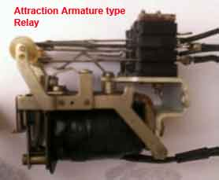

[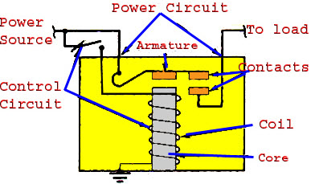](https://www.elprocus.com/wp-content/uploads/2014/03/39.jpg)

Hinged armature and plunger type constructions are most commonly used for these **types of electromagnetic relays**. Among these two constructional design, hinged armature type is more commonly used.  
We know that force exerted on an armature is directly proportional to the square of the [magnetic flux](https://www.electrical4u.com/what-is-magnetic-field/#Magnetic-Flux-or-Magnetic-Lines-of-Force) in the air gap. If we ignore the effect of saturation, the equation for the force experienced by the armature can be expressed as,https://www.electrical4u.com/equations/er-05-06-14-01.gifWhere, F is the net force, K' is constant, I is rms [current](https://www.electrical4u.com/electric-current-and-theory-of-electricity/) of armature coil, and K' is the restraining force.  
The threshold condition for relay operation would therefore be reached when KI2 = K'.  
If we observe the above equation carefully, it would be realized that the relay operation is dependent on the constants K' and K for a particular value of the coil current.  
From the above explanation and equation it can be summarized that, the operation of relay is influenced by

1. Ampere – turns developed by the relay operating coil,
2. The size of air gap between the relay core and the armature,
3. Restraining force on the armature.

### Construction of Attracted Type Relay

This relay is essentially a simple electromagnetic coil, and a hinged plunger. Whenever the coil becomes energized the plunger being attracted towards core of the coil. Some NO-NC (Normally Open and Normally Closed) contacts are so arranged mechanically with this plunger, that, NO contacts become closed and NC contacts become open at the end of the plunger movement. Normally **attraction armature type relay** is DC operated relay. The contacts are so arranged, that, after relay is operated, the contacts cannot return their original positions even after the armature is de energized. After relay operation, this types of electromagnetic relays are reset manually.  
Attraction armature relay by virtue of their construction and working principle, is instantaneous in operation.

## Induction Disc Type Relay

**Induction disc type relay** mainly consists of one rotating disc.

### Induction Disc type Relay Working

Every **induction disc type relay** works on the same well known Ferraries principle. This principle says, a torque is produced by two phase displaced fluxes, which is proportional to the product of their magnitude and phase displacement between them. Mathematically it can be expressed as-https://www.electrical4u.com/equations/er-05-06-14-02.gif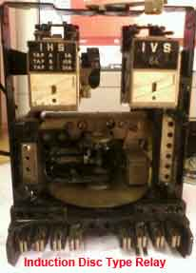

[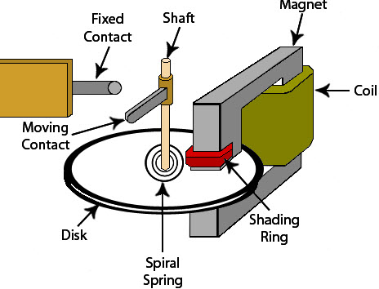](https://www.elprocus.com/wp-content/uploads/2014/03/410.jpg)

The induction disc type relay is based on the same principle as that of an [ammeter](https://www.electrical4u.com/ammeter/) or a volt meter, or a [wattmeter](https://www.electrical4u.com/electrodynamometer-type-wattmeter/) or a watt hour mater. In induction relay the deflecting torque is produced by the [eddy currents](https://www.electrical4u.com/hysteresis-eddy-current-iron-or-core-losses-and-copper-loss-in-transformer/) in an aluminium or copper disc by the [flux](https://www.electrical4u.com/what-is-flux-types-of-flux/) of an AC electromagnet. Here, an aluminium (or copper) disc is placed between the poles of an AC magnet which produces an alternating flux φ lagging from I by a small angle. As this flux links with the disc, there must be an induced emf E2 in the disc, lagging behind the flux φ by 90o. As the disc is purely resistive, the induced current in the disc I2 will be in phase with E2. As the angle between φ and I2 is 90o, the net torque produced in that case is zero. As,https://www.electrical4u.com/equations/er-05-06-14-03.gifIn order to obtain torque in induction disc type relay, it is necessary to produce a rotating field.

### Pole Shading Method of Producing Torque in Induction Disc Relay

In this method half of the pole is surrounded with copper ring as shown. Let φ1 is the flux of unshaded portion of the pole. Actually total flux divided into two equal portions when the pole is divided into two parts by a slot.https://www.electrical4u.com/equations/er-05-06-14-04.gifAs the one portion of the pole is shaded by copper ring. There will be induced current in the shade ring which will produce another flux φ2' in the shaded pole. So, resultant flux of shaded pole will be vector sum of φ1 and φ2. Say it is φ2, and angle between φ1 and φ2 is θ. These two fluxes will produce a resultant torque,https://www.electrical4u.com/equations/er-05-06-14-05.gifThere are mainly three types of shape of rotating disc are available for induction disc type relay. They are spiral shaped, round and vase shaped, as shown. The spiral shape is done to compensate against varying restraining torque of the control spring which winds up as the disc rotates to close its contacts. For most designs, the disc may rotate by as much as 280o. Further, the moving contact on the disc shift is so positioned that it meets the stationary contacts on the relay frame when the largest radius section of the disc is under the electromagnet. This is done to ensure satisfactory contact pressure in induction disc type relay.  
Where high speed operation is required, such as in differential protection, the angular travel of the disc is considerably limited and hence circular or even vane types may be used in induction disc type electromagnetic relay.

Some time it is required that operation of an induction disc type relay should be done after successful operation of another relay. Such as inter locked over current relays are generally used for generator and bus bar protection. In that case, the shading band is replaced by a shading coil. Two ends of that shading coil are brought out across a normally open contact of other control device or relay. Whenever the latter is operated the normally open contact is closed and makes the shading coil short circuited. Only after that the over current relay disc starts rotating.  
One can also change the time / current characteristics of an induction disc type relay, by deploying variable [resistance](https://www.electrical4u.com/electrical-resistance-and-laws-of-resistance/) arrangement to the shading coil.  
Induction disc relay fed off a negative sequence filter can also be used as Negative-sequence protection device for [alternators](https://www.electrical4u.com/alternator-or-synchronous-generator/).

## Induction Cup Type Relay

**Induction cup type relay** can be considered as a different version of induction disc type relay. The working principle of both type of relays are more or less some. [Induction cup type relay](https://www.electrical4u.com/working-principle-construction-and-types-of-induction-cup-relay/) are used where, very high speed operation along with polarizing and/or differential winding is requested. Generally four pole and eight pole design are available. The number of poles depends upon the number of winding to be accommodated.  
The inertia of cup type design is much lower than that of disc type design. Hence very high speed operation is possible in induction cup type relay. Further, the pole system is designed to give maximum torque per KVA input. In a four pole unit almost all the eddy currents induced in the cup by one pair of poles appear directly under the other pair of poles – so that torque / VA is about three times that of an induction disc with a c-shaped electromagnet.  
**Induction cup type relay** is practically suited as directional or phase comparison units. This is because, besides their sensitivity, [induction cup relay](https://www.electrical4u.com/working-principle-construction-and-types-of-induction-cup-relay/) have steady non vibrating torque and their parasitic torque due to current or voltage alone are small. 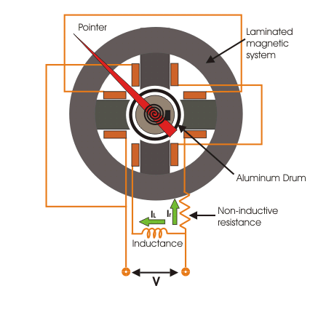

### Induction Cup Type Directional or Power Relay

It in a four pole induction cup type relay, one pair of poles produces flux proportional to voltage and other pair of poles produces flux proportional to current. The vector diagram is given below,  
The torque T1 = Kφvi.φi. sin(90o − θ) assuming flux produced by the voltage coil will lag 90° behind its voltage. By design, the angle can be made to approach any value and a torque equation T = K.E.I.cos(φ − θ) obtained, where θ is the E - I system angle.  
Accordingly, induction-cup type relay can be designed to produced maximum torque When system angle θ = 0o or 30o or 45o or 60o. The former is known as power relays as they produce maximum torque when θ = 0o and latter are known as directional relays – they are used for directional discrimination in protective schemes under fault conditions, as they are designed to produce maximum torque at faulty conditions.

### Reactance or Mho Type Induction Cup Relay

By manipulating the current or voltage coil arrangements and the relative phase displacement angle between various fluxes, induction cup type relay can be made to measure pure reactance of a power circuit.

## Balanced Beam Relay

Balanced beam type relay can be said a variant of attraction armature type relay, but still these are treated as different types of relay as they are employed in different field of application.  
Balanced beam type relays were used in differential and distance protection schemes. The use of these relay becomes absolute as sophisticated induction disc type relay and [induction cup type relays](https://www.electrical4u.com/working-principle-construction-and-types-of-induction-cup-relay/) supersede them.  
The working principle of a Balance Beam Relay is quite simple. Here one beam is supported by one hinge. The hinge supports the beam from some where in the middle of the beam. There are two forces acts on two ends of the beams, respectively. The direction of both of the forces are same. Not only direction, in normal working condition the torque produced by the forces in respect of the hinge, are also same. Due to these two same directional torques, the beam is held in horizontal position in normal working condition. One of these torques is restraining torque and other is operating torque.  
The restraining torque can be provided either by restraining coil or by restraining spring.  
This is a kind of attracted armature type relay. But balance beam relay is treated separately from their application point of view. When any fault occurred, the current through the operating coil, crosses its pick up value, and hence the mmf of operating coil increases and crosses its pick-up value. Due to this increased mmf, the coil attracts more strongly the beam end and hence, torque on respective end of the beam increases. As this torque is increased, the balance of the beam is being disturbed. Due to this unbalanced torque condition, the beam end associated with operating torque, moves downward, to close No contacts of the relay.  
Typical arrangement of both types of balance beam relay are illustrated below :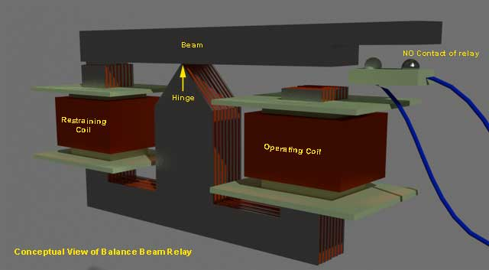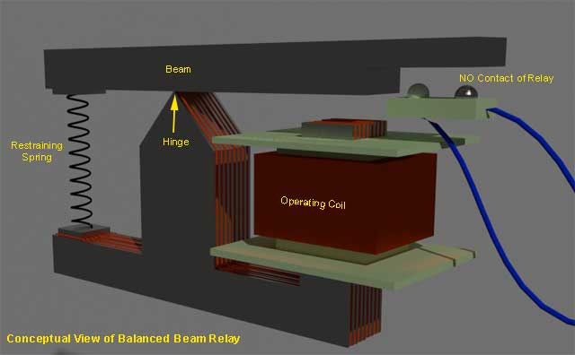Now-a-days, balance beam relays become obsolete. In past these relays were widely used in differential and impedance measurements. The use of these relays are superseded by more sophisticated induction disc and cup type relays.  
The main drawbacks of balance beam relay, is poor reset / operate ratio, susceptibility to phase displacement between the two energizing and mal-operation on transients.

## Moving Coil Type Relay

The **moving coil relay** or polarized DC moving coil relay is most sensitive electromagnetic relay. Because of its high sensitive, this relay is used widely for sensitive and accurate measurement for distance and differential protection. This type of relays is inherently suitable for DC system. Although this type of relay can be used for A.C system also but necessary rectifier circuit should be provided in current [transformer](https://www.electrical4u.com/what-is-transformer-definition-working-principle-of-transformer/).  
In a **moving coil relay** the movement of the coil may be rotary or axial. Both of them have been perfected to a large extent by the various manufactures but the inherent limitation of a moving coil relay remains i.e to lead the current in and out of the moving coil system which, far reasons of sensitivity has to be designed to be very delicate.  
Between these two types of moving coil relay a axial moving type has twice sensitivity than that of rotary type. With moving coil relay, sensitivities of the order of 0.2 mW to 0.5 mW are typical. Speed of operation depends upon damping provided in the relay.

**Over Current Relay**

## Working Principle of Over Current Relay

In an **over current relay**, there would be essentially a current coil. When normal current flows through this coil, the magnetic effect generated by the coil is not sufficient to move the moving element of the relay, as in this condition the restraining force is greater than deflecting force. But when the current through the coil increased, the magnetic effect increases, and after certain level of current, the deflecting force generated by the magnetic effect of the coil, crosses the restraining force, as a result, the moving element starts moving to change the contact position in the relay.Although there are different **types of over current relays** but basic **working principle of over current relay** is more or less same for all.

## Types of Over Current Relay

Depending upon time of operation, there are various **types of Over Current relays**, such as,

1. **Instantaneous over current relay**.
2. **Definite time over current relay**.
3. **Inverse time over current relay**.

**Inverse time over current relay** or simply **inverse OC relay** is again subdivided as **inverse definite minimum time** (IDMT), **very inverse time**, **extremely inverse time over current relay** or **OC relay**.

### Instantaneous Over Current Relay

Construction and working principle of **instantaneous over current relay** quite simple.

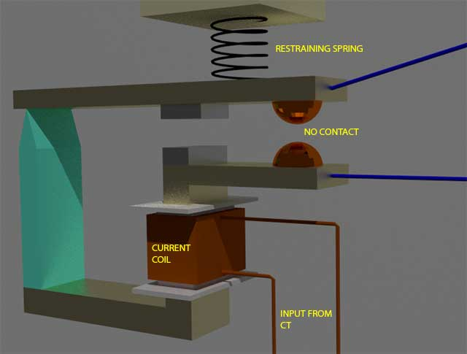

Here generally a magnetic core is wound by current coil. A piece of iron is so fitted by hinge support and restraining spring in the relay, that when there is not sufficient current in the coil, the NO contacts remain open. When current in the coil crosses a present value, the attractive force becomes sufficient to pull the iron piece towards the magnetic core and consequently the no contacts are closed.

The preset value of current in the relay coil is referred as pick up setting current. This relay is referred as instantaneous **over current relay**, as ideally, the relay operates as soon as the current in the coil gets higher than pick up setting current. There is no intentional time delay applied. But there is always an inherent time delay which can not be avoided practically. In practice the operating time of an instantaneous relay is of the order of a few milliseconds. Fig.

### Definite Time Over Current Relay

This relay is created by applying intentional time delay after crossing pick up value of the current. A **definite time over current relay** can be adjusted to issue a trip output at definite amount of time after it picks up. Thus, it has a time setting adjustment and pick up adjustment.

### Inverse Time Over Current Relay

Inverse time is a natural character of any induction type rotating device. This means the speed of rotation of rotating art of the device is faster if input current is increased. In other words, time of operation inversely varies with input current. This natural characteristic of electromechanical induction disc relay in very suitable for over current protection. This is because, in this relay, if fault is more severe, it would be cleared more faster. Although time inverse characteristic is inherent to electromechanical induction disc relay, but the same characteristic can be achieved in microprocessor based relay also by proper programming.

### Inverse Definite Minimum Time Over Current Relay or IDMT O/C Relay

Ideal inverse time characteristics can not be achieved, in an over current relay. As the current in the system increases, the secondary current of the [current transformer](https://www.electrical4u.com/current-transformer-ct-class-ratio-error-phase-angle-error-in-current-transformer/) is increased proportionally. The secondary current is fed to the relay current coil. But when the CT becomes saturated, there would not be further proportional increase of CT secondary current with increased system current. From this phenomenon it is clear that from trick value to certain range of faulty level, an inverse time relay shows exact inverse characteristic. But after this level of fault, the [CT](https://www.electrical4u.com/current-transformer-ct-class-ratio-error-phase-angle-error-in-current-transformer/) becomes saturated and relay current does not increase further with increasing faulty level of the system. As the relay current is not increased further, there would not be any further reduction in time of operation in the relay. This time is referred as minimum time of operation. Hence, the characteristic is inverse in the initial part, which tends to a definite minimum operating time as the current becomes very high. That is why the relay is referred as **inverse definite minimum time over current relay** or simply **IDMT relay**.

**Differential relays**

The relays used in [power system protection](https://electrical4u.com/protection-system-in-power-system/) are of different types. Among them **differential relay** is very commonly used relay for [protecting transformers](https://electrical4u.com/transformer-protection-and-transformer-fault/) and generators from localised faults.  
**Differential relays** are very sensitive to the faults occurred within the zone of protection but they are least sensitive to the faults that occur outside the protected zone. Most of the relays operate when any quantity exceeds beyond a predetermined value for example [over current relay](https://electrical4u.com/over-current-relay-working-principle-types/) operates when [current](https://www.electrical4u.com/electric-current-and-theory-of-electricity/) through it exceeds predetermined value. But the [principle of differential relay](https://electrical4u.com/differential-protection-of-transformer-differential-relays/#Principle-of-Differential-Protection) is somewhat different. It operates depending upon the difference between two or more similar electrical quantities.

The differential relay is one that operates when there is a difference between two or more similar electrical quantities exceeds a predetermined value. In differential relay scheme circuit, there are two currents come from two parts of an [electrical power](https://www.electrical4u.com/electric-power-single-and-three-phase/) circuit.

These two currents meet at a junction point where a relay coil is connected. According to [Kirchhoff Current Law](https://electrical4u.com/kirchhoff-current-law-and-kirchhoff-voltage-law/#Kirchhoff's-Current-Law), the resultant current flowing through the relay coil is nothing but summation of two currents, coming from two different parts of the electrical power circuit. If the polarity and amplitude of both currents are so adjusted that the phasor sum of these two currents, is zero at normal operating condition. Thereby there will be no current flowing through the relay coil at normal operating conditions. But due to any abnormality in the power circuit, if this balance is broken, that means the phasor sum of these two currents no longer remains zero and there will be non-zero current flowing through the relay coil thereby relay being operated. In current differential scheme, there are two sets of [current transformer](https://electrical4u.com/current-transformer-ct-class-ratio-error-phase-angle-error-in-current-transformer/) each connected to either side of the equipment protected by **differential relay**. The ratio of the current transformers are so chosen, the secondary currents of both current transformers matches each other in magnitude. The polarity of current transformers are such that the secondary currents of these [CTs](https://www.electrical4u.com/current-transformer-ct-class-ratio-error-phase-angle-error-in-current-transformer/) opposes each other. From the circuit is clear that only if any nonzero difference is created between this to secondary currents, then only this differential current will flow through the operating coil of the relay. If this difference is more than the peak up value of the relay, it will operate to open the [circuit breakers](https://electrical4u.com/electrical-circuit-breaker-operation-and-types-of-circuit-breaker/) to isolate the protected equipment from the system. The relaying element used in differential relay is [attracted armature type instantaneously relay](https://electrical4u.com/instantaneous-relay/) since differential scheme is only adapted for clearing the fault inside the protected equipment in other words differential relay should clear only internal fault of the equipment hence the protected equipment should be isolated as soon as any fault occurred inside the equipment itself. They need not be any time delay for coordination with other relays in the system.

## Types of Differential Relay

There are mainly two **types of differential relay** depending upon the principle of operation.

1. Current Balance Differential Relay
2. Voltage Balance Differential Relay

In **current differential relay** two current transformers are fitted on the either side of the equipment to be protected. The secondary circuits of CTs are connected in series in such a way that the carry secondary CT current in same direction. The operating coil of the relaying element is connected across the CT’s secondary circuit. Under normal operating conditions, the protected equipment (either power transformer or [alternator](https://www.electrical4u.com/alternator-or-synchronous-generator/)) carries normal current. In this situation, say the secondary current of CT1 is I1 and secondary current of CT2 is I2. It is also clear from the circuit that the current passing through the relay coil is nothing but I1-I2. As we said earlier, the current transformer’s ratio and polarity are so chosen, I1 = I2, hence there will be no current flowing through the relay coil. Now if any fault occurs external to the zone covered by the CTs, faulty current passes through primary of the both current transformers and thereby secondary currents of both current transformers remain same as in the case of normal operating conditions. Therefore at that situation the relay will not be operated. But if any ground fault occurred inside the protected equipment as shown, two secondary currents will be no longer equal. At that case the differential relay is being operated to isolate the faulty equipment ([transformer](https://www.electrical4u.com/what-is-transformer-definition-working-principle-of-transformer/) or alternator) from the system.  
Principally this [type of relay](https://electrical4u.com/types-of-electrical-protection-relays-or-protective-relays/) systems suffers from some disadvantages

1. There may be a probability of mismatching in cable impedance from CT secondary to the remote relay panel.
2. These pilot cables’ capacitance causes incorrect operation of the relay when large through fault occurs external to the equipment.
3. Accurate matching of characteristics of current transformer cannot be achieved hence there may be spill current flowing through the relay in normal operating conditions.

## Percentage Differential Relay

This is designed to response to the differential current in the term of its fractional relation to the current flowing through the protected section. In this type of relay, there are restraining coils in addition to the operating coil of the relay. The restraining coils produce torque opposite to the operating torque. Under normal and through fault conditions, restraining torque is greater than operating torque. Thereby relay remains inactive. When internal fault occurs, the operating force exceeds the bias force and hence the relay is operated. This bias force can be adjusted by varying the number of turns on the restraining coils. As shown in the figure below, if I1 is the secondary current of CT1 and I2 is the secondary current of CT2then current through the operating coil is I1 - I2 and current through the restraining coil is (I1+ I2)/2. In normal and through fault condition, torque produced by restraining coils due to current (I1+ I2)/2 is greater than torque produced by operating coil due to current I1- I2 but in internal faulty condition these become opposite. And the bias setting is defined as the ratio of (I1- I2) to (I1+ I2)/2It is clear from the above explanation, greater the current flowing through the restraining coils, higher the value of the current required for operating coil to be operated. The relay is called percentage relay because the operating current required to trip can be expressed as a percentage of through current.

### CT Ratio and Connection for Differential Relay

This simple thumb rule is that the current transformers on any star winding should be connected in delta and the current transformers on any delta winding should be connected in star. This is so done to eliminate zero sequence current in the relay circuit.

If the CTs are connected in star, the CT ratio will be In/1 or 5 A  
CTs to be connected in delta, the CT ratio will be In/0.5775 or 5×0.5775 A

## Voltage Balance Differential Relay

In this arrangement the current transformer are connected either side of the equipment in such a manner that EMF induced in the secondary of both current transformers will oppose each other. That means the secondary of the current transformers from both sides of the equipment are connected in series with opposite polarity. The differential relay coil is inserted somewhere in the loop created by series connection of secondary of current transformers as shown in the figure. In normal operating conditions and also in through fault conditions, the EMFs induced in both of the CT secondary are equal and opposite of each other and hence there would be no current flowing through the relay coil. But as soon as any internal fault occurs in the equipment under protection, these EMFs are no longer balanced hence current starts flowing through the relay coil thereby trips circuit breaker.

There are some disadvantages in the [voltage](https://www.electrical4u.com/voltage-or-electric-potential-difference/) balance differential relay such as A multy tap transformer construction is required to accurate balance between current transformer pairs. The system is suitable for protection of cables of relatively short length otherwise [capacitance](http://www.electrical4u.com/what-is-capacitor-and-what-is-dielectric/) of pilot wires disturbs the performance. On long cables the charging current will be sufficient to operate the relay even if a perfect balance of current transformer achieved.

These disadvantages can be eliminated from the system by introducing translay system which is nothing but modified balance voltage differential relay system. Translay scheme is mainly applied for differential protection of feeders. Here, two sets of current transformers are connected either end of the feeder. Secondary of each current transformer is fitted with individual double winding induction type relay. The secondary of each current transformer feeds primary circuit of double winding induction type relay. The secondary circuit of each relay is connected in series to form a closed loop by means of pilot wires. The connection should be such that, the induced voltage in secondary coil of one relay will oppose same of other. The compensating device neutralises the effect of pilot wires capacitance currents and effect of inherent lack of balance between the two current transformers. Under normal conditions and through fault conditions, the current at two ends of the feeder is same thereby the current induced in the CT’s secondary would also be equal. Due to these equal currents in the CT’s secondary, the primary of each relay induce same EMF. Consequently, the EMF induced in the secondaries of the relays are also same but the coils are so connected, these EMFs are in opposite direction. As a result, no current will flow through the pilot loop and thereby no operating torque is produced either of the relays. But if any fault occurs in the feeder within the zone in between current transformers, the current leaving the feeder will be different from the current entering into the feeder. Consequently, there will be no equality between the currents in both CT secondaries. These unequal secondary CT currents will produce unbalanced secondary induced voltage in both of the relays. Therefore, current starts circulating in the pilot loop and hence torque is produced in both of the relays. As the direction of secondary current is opposite into relays, therefore, the torque in one relay will tend to close the trip contacts and at the same time torque produced in other relay will tend to hold the movement of the trip contacts in normal un-operated position. The operating torque depends upon the position and nature of faults in the protected zone of feeder. The faulty portion of the feeder is separated from healthy portion when at least one element of either relay operates.

This can be noted that in translay protection scheme, a closed copper ring is fitted with the Central limb of primary core of the relay. These rings are utilised to neutralise the effect of pilot capacity currents. Capacity currents lead the voltage impressed of the pilot by 90o and when they flow in low inductive operating winding, produce flux that also leads the pilot voltage by 90o. Since the pilot voltage is that induced in the secondary coils of the relay, it lags by a substantial angle behind the [flux](https://www.electrical4u.com/what-is-flux-types-of-flux/) in the field magnetic air gap. The closed copper rings are so adjusted that the angle is approximately 90o. In this way fluxes acting on the disk are in phase and hence no torque is exerted in the relay disc.

**Distance Relay**

There is one type of relay which functions depending upon the distance of fault in the line. More specifically, the relay operates depending upon the impedance between the point of fault and the point where relay is installed. These relays are known as **distance relay** or **impedance relay**.

## Working Principle of Distance or Impedance Relay

The **working principle of distance relay** or **impedance relay** is very simple. There is one [voltage](https://www.electrical4u.com/voltage-or-electric-potential-difference/) element from [potential transformer](https://www.electrical4u.com/voltage-transformer-or-potential-transformer-theory/) and an [current](https://www.electrical4u.com/electric-current-and-theory-of-electricity/) element fed from [current transformer](https://www.electrical4u.com/current-transformer-ct-class-ratio-error-phase-angle-error-in-current-transformer/) of the system. The deflecting torque is produced by secondary current of [CT](https://www.electrical4u.com/current-transformer-ct-class-ratio-error-phase-angle-error-in-current-transformer/) and restoring torque is produced by voltage of potential transformer.

In normal operating condition, restoring torque is more than deflecting torque. Hence relay will not operate. But in faulty condition, the current becomes quite large whereas voltage becomes less. Consequently, deflecting torque becomes more than restoring torque and dynamic parts of the relay starts moving which ultimately close the No contact of relay. Hence clearly **operation or working principle of distance relay**, depends upon the ratio of system voltage and current. As the ratio of voltage to current is nothing but impedance a distance relay is also known as impedance relay.  
The operation of such relay depends upon the predetermined value of voltage to current ratio. This ratio is nothing but impedance. The relay will only operate when this voltage to current ratio becomes less than its predetermined value. Hence, it can be said that the relay will only operate when the impedance of the line becomes less than predetermined impedance (voltage / current). As the impedance of a [transmission line](https://www.electrical4u.com/transmission-line-in-power-system/) is directly proportional to its length, it can easily be concluded that a distance relay can only operate if fault is occurred within a predetermined distance or length of line.

## Types of Distance or Impedance Relay

There are mainly two **types of distance relay**-

1. **Definite distance relay**.
2. **Time distance relay**.

Let us discuss one by one.

### Definite Distance Relay

This is simply a variety of balance beam relay. Here one beam is placed horizontally and supported by hinge on the middle. One end of the beam is pulled downward by the magnetic force of voltage coil, fed from potential transformer attached to the line. Other end of the beam is pulled downward by the magnetic force of current coil fed from current transformer connected in series with line. Due to torque produced by these two downward forces, the beam stays at an equilibrium position. The torque due to voltage coil, serves as restraining torque and torque due to current coil, serves as deflecting torque.

Under normal operating condition restraining torque is greater than deflecting torque. Hence contacts of this distance relay remain open. When any fault is occurred in the feeder, under protected zone, voltage of feeder decreases and at the same time current increases. The ratio of voltage to current i.e. impedance falls below the pre-determined value. In this situation, current coil pulls the beam more strongly than voltage coil, hence beam tilts to close the relay contacts and consequently the [circuit breaker](https://www.electrical4u.com/electrical-circuit-breaker-operation-and-types-of-circuit-breaker/) associated with this impedance relay will trip.

### Time Distance Impedance Relay

This delay automatically adjusts its operating time according to the distance of the relay from the fault point. The time distance impedance relay not only be operated depending upon voltage to current ratio, its operating time also depends upon the value of this ratio. That means,https://www.electrical4u.com/equations/dr-05-06-14-01.gif

#### Construction of Time Distance Impedance Relay

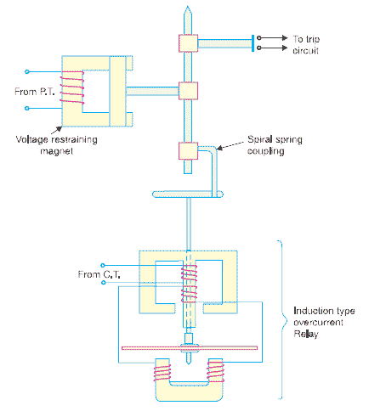The relay mainly consists of a current driven element like double winding type induction over current relay. The spindle carrying the disc of this element is connected by means of a spiral spring coupling to a second spindle which carries the bridging piece of the relay contacts. The bridge is normally held in the open position by an armature held against the pole face of an electromagnet excited by the voltage of the circuit to be protected.

#### Operating Principle of Time Distance Impedance Relay

During normal operating condition the attraction force of armature fed from PT is more than force generated by induction element, hence relay contacts remain in open position when a short circuit fault occurs in the transmission line, the current in the induction element increases. Then the induction in the induction element increases. Then the induction element starts rotating. The speed of rotation of induction elements depends upon the level of fault i.e. quantity of current in the induction element. As the rotation of the disc proceeds, the spiral spring coupling is wound up till the tension of the spring is sufficient to pull the armature away from the pole face of the voltage excited magnet.

The angle through which the disc travels the disc travel before relay operate depends upon the pull of the voltage excited magnet. The greater the pull, the greater will be the travel of the disc. The pull of this magnet depends upon the line voltage. The greater the line voltage the greater the pull hence longer will be the travel of the disc i.e. operating time is proportional to V.  
Again, speed of rotation of induction element approximately proportional to current in this element. Hence, time of operation is inversely proportional to current.https://www.electrical4u.com/equations/dr-05-06-14-02.gifTherefore time of operation of relay,https://www.electrical4u.com/equations/dr-05-06-14-03.gif

## Instantaneous Relay

An **instantaneous relay** is one in which there is no time delay provided intentionally. More specifically ideally there is no time required to operate the relay. Although there is some time delay which can not be avoided.

As the current coil is an [inductor](https://www.electrical4u.com/what-is-inductor-and-inductance-theory-of-inductor/), there would be a certain delay to reach the current in the coil to its maximum value. There is also some time required for mechanical movement plunger in the relay. These time delays are inherent in the instantaneous relay but no other time delay is intentionally added. These relays can be operated in less than 0.1 sec.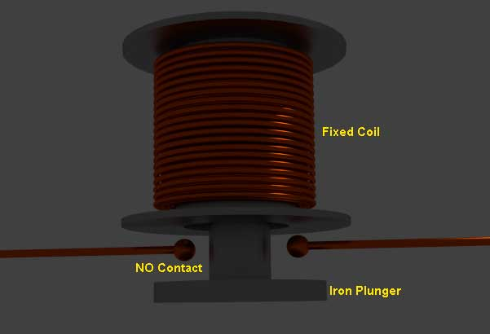

## Examples of Instantaneous Relays

There are various types of relay which can be considered as instantaneous relay. Such as, attracted armature relay where an iron plunger is attracted by an electromagnet to actuate the relay. When attractive force of the electromagnet crosses its pick up level, the iron plunger starts move towards the magnet and crosses the relay contacts. The magnetic strength of the electromagnet, depends upon the current flows the coil conductors.  
Another popular **example of instantaneous relay**, is solenoid type relay. When current in the solenoid crosses pick up value, the solenoid attracts an iron plunger which moves to close the relay contacts.  
Balance beam relay is also an well known example of **instantaneous relay**. Here balance of one horizontally placed beam is disturbed due to pick up current in the relay coil. Due to unequal torques at two ends of the beam, it starts rotating against the hinge and ultimately closes the contacts of the relay.

**Inverse time relay**

In this type of relays, the time of operation depends upon the magnitude of actuating quantity. If the magnitude of actuating quantity is very high, the relay operation is very fast. In other words, the relay operating time that is time delay in the relay is inversely proportional to the magnitude of actuating quantity.  
The general **characteristics of an inverse time relay** is shown in figure below.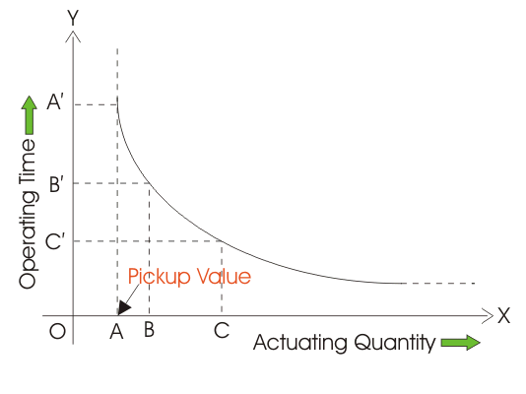Here, in the graph it is clear that, when, actuating quantity is OA, the operating time of the relay is OA', when actuating quantity is OB, the relay operating time is OB' and when actuating quantity is OC, the relay operating quantity is OC'.

In the graph above, it is also observed that, when actuating quantity is less than OA, the relay operating time becomes infinity, that means for actuating quantity less than OA, the relay does not at all actuate. This minimum value of actuating quantity for which a relay initiates its operation is known as pick up value of actuating quantity. Here it is denoted as OA.  
It is also seen from the graph that, when actuating quantity approaches to infinity along x axis the operating time does not approach to zero. The curve approaches to an approximately constant operating time. This is approximately minimum time required to operate the relay.

The **inverse time relay**, where the actuating quantity is [current](https://www.electrical4u.com/electric-current-and-theory-of-electricity/), is known as inverse current relay.  
In this type of relay, the inverse time is achieved by attaching some mechanical accessories in the relay.  
Inverse time delay is achieved in induction disc relay by providing a permanent magnet in such a way, that, when disc rotates, it cuts the [flux](https://www.electrical4u.com/what-is-flux-types-of-flux/) of permanent magnet. Due to this, current is induced in the disc which slows down the movement of the disc. A solenoid relay can be made **inverse time relay**, by providing a piston and a oil dash-pot. A piston, attached to the moving iron plunger, is immersed in oil in a dash-pot. When the solenoid relay is actuated, the piston moves upwards along with iron plunger. Viscosity of oil slows the upward movement of plunger. The speed of this upward movement against gravity also depends upon how strongly the solenoid attracts the iron plunger. This attraction force of the solenoid depends upon the magnitude of actuating current. Hence, time of operation of relay is inversely proportional to actuating current.

## Definite Time Lag Relay

During relay coordination in electrical power system protection scheme, there is some time intentionally required, to operate some specific relays after some specific time delays. Definite time lag relays are those which operate after a specific time. The time lag between instant when the actuating current crosses the pick up level and the instant when relay contacts finally closed, is constant. This delay does not depend up on magnitude of actuating quantity. For all actuating quantity, above pick up values, the relay operating time is constant.